**WHEELS 👨‍🔧⚙️👩‍🔧**

We need to design wheels for Shiv Nadar IoE’s rover for the NASA Human Exploration Rover Challenge. The challenge, consisting of an obstacle course, has various obstacles such as the ‘Crater with Ejecta’, which requires the participants to drive their rover over craters of 6 feet diameter and 8 inches height. Such a challenge requires us to build strong wheels which are wide enough to sustain the aforementioned challenge. Other challenges like the ‘Transverse Incline’, ‘Martian Terrain High Butte’, and ‘Large Ravine - Martian Terrain’ require the wheels to have a strong grip to be able to traverse various terrains. Also, the challenge requires us to design and fabricate non-pneumatic wheels.

**Exact instruction on wheels from the handbook**:

On accounting for all of these challenges that our rover will face, we have come up with the following design for the wheels of the rover.

The rover will consist of four wheels. All wheels will have the same diameter measuring 26 inches. A total of 6 wheels will be manufactured; 2 for the front, 2 for the back and 1 spare for each of them.

For each wheel, we will be using two standard rims used in cycles (details TBD). These rims will be welded together, while leaving a small gap between the two rims, such that the total edge-to-edge width of the two rims is between 5 to 6 inches, by using small metallic strips, preferably of the same material, joining them at their circumference.

To make the joining of the rims stronger, a metallic sheet of the same material as the strips, and thickness around 2.5 - 3 mm will be welded to cover the entire outer surface of the wheel. This whole construction leads to an overall wheel of more than double the width of a standard cycle wheel.

Next, we focus on increasing the grip of the wheels. The double-rimmed wheel once covered with the metallic sheet will now be covered with a thick sheet of truck tyre rubber, of thickness around 1.5 cm. To stick the rubber sheet to the metallic part of the wheel, we will be bolting the rubber sheet to the wheel by drilling and tightening it by nuts from inside. To increase the grip of the wheel more, we will be drilling bolts onto the surface of the wheel on the sides and using nuts to fasten them from the inside. The bolts will be arranged at the outer edges of the wheel in two circles along the edges of the wheel. The approximate spacing between consecutive bolts would be 2-3 cm, giving a total of almost 200 bolts on each wheel arranged in parallel circles. The rough sketch below will help in giving an idea of how the bolts are placed.

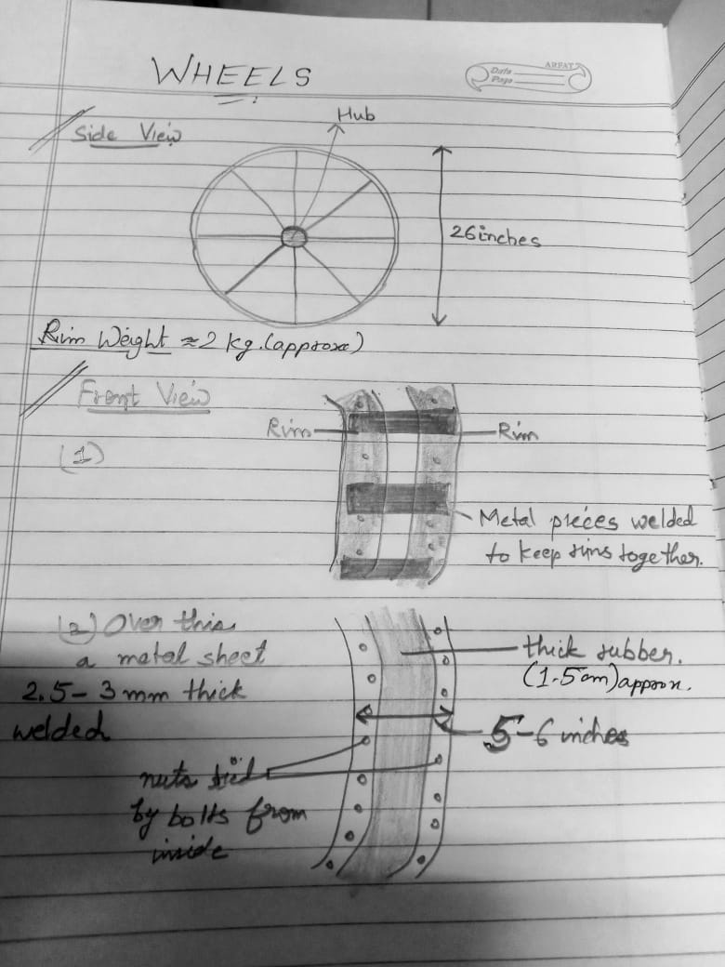

**What we still need to work on**

* What kind of rims will be used (what will be its material, number of spokes, strength, etc) ? (requires visit to Dadri cycle shops)
* The kind of materials used in the metallic sheet for the wheel? (depends on the material of the rim, needs to be easily weldable)
* Diameter of the shaft

**References**

1. [Driving on handmade all-terrain tires - YouTube](https://www.youtube.com/watch?v=tD7Kkfh2rkA): This video has the construction of DIY all-terrain wheels, which uses the same idea for drilling bolts for added grip to the wheels.

1. <https://www.amazon.in/BALAJI-STORES-Stainless-Steel-Cycle/dp/B0BQTYN31V/ref=sr_1_13?keywords=cycle+rim&qid=1673934628&sr=8-13>

CYCLE RIM-1                           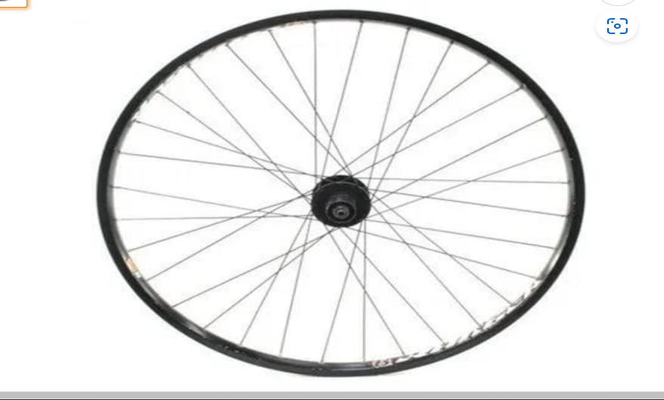

1. <https://www.amazon.in/Autonix-Aluminium-Wheel-Spoke-Axle/dp/B08BXLLMRB/ref=d_pd_sbs_sccl_3_1/260-2155128-2001758?pd_rd_w=3cZl3&content-id=amzn1.sym.e2ce9e2f-6d12-4c08-abc6-a5b1e7e9208f&pf_rd_p=e2ce9e2f-6d12-4c08-abc6-a5b1e7e9208f&pf_rd_r=Q6D7WAPJCWRTP9KREBJS&pd_rd_wg=sVswl&pd_rd_r=37f93c47-9cd5-4526-8b65-42f074327f6b&pd_rd_i=B08BXLLMRB&psc=1>

CYCLE RIM-2                              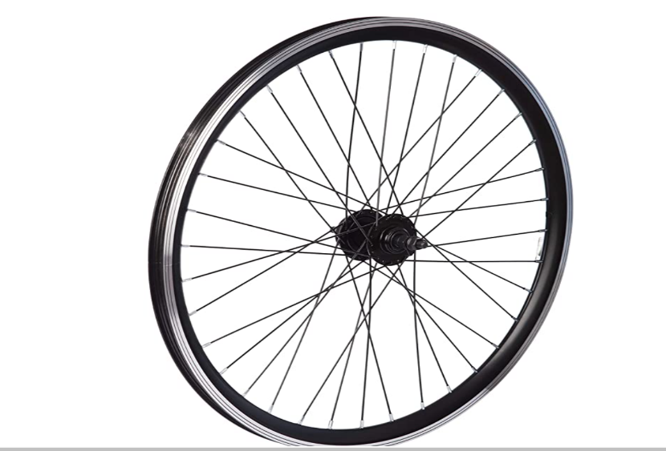

1. <https://www.amazon.in/Invento-Aluminium-Alloy-Sheet-100x100x2mm/dp/B074FW2WLT/ref=sr_1_11?crid=THUNN6DEYK8W&keywords=metal+sheet&qid=1673957884&sprefix=metal+sheet+%2Caps%2C541&sr=8-11>

METAL SHEET

